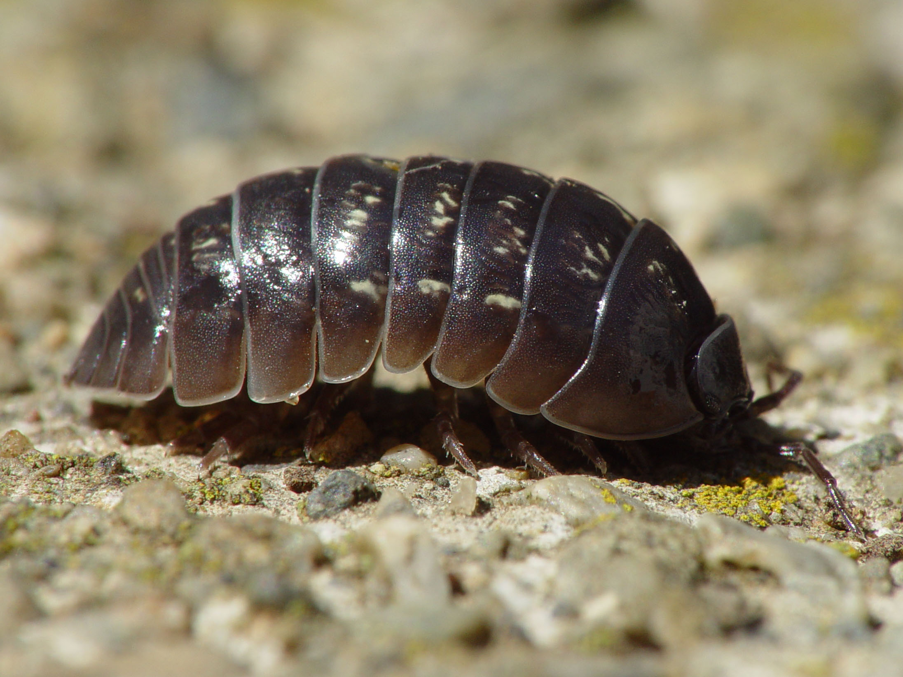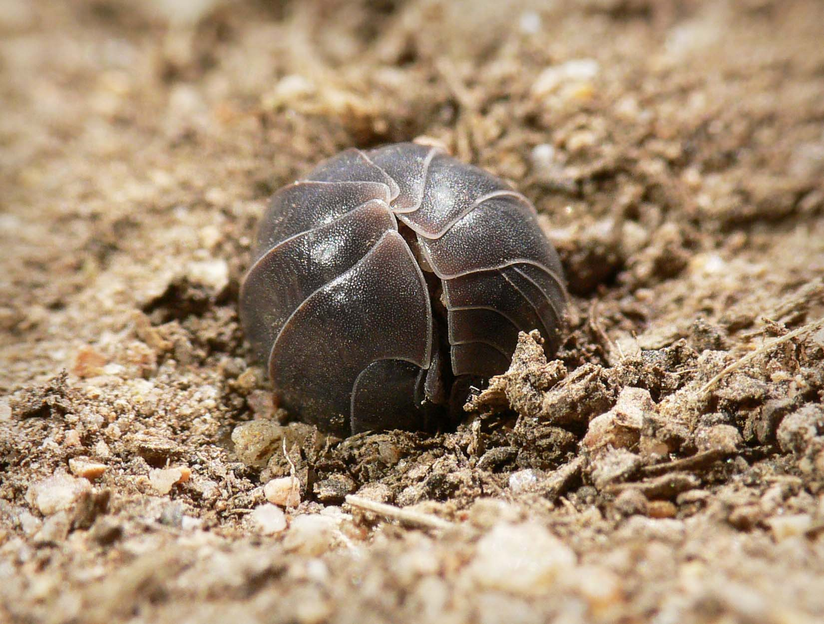

**Wood Bug Lab Experiment**

**hhhhhhhhhhhhhhhhhhhhhhhhhhhhhhhhhhhhhhhhhhhhhhhhhhhhhhhhhhh**

Measuring the Activity of Wood Bugs in Different Environments

**Maxwell Nielsen**

**Andy Shang**

**Adib Etemadi**

**12/9/17**

Block 3, Room 310

Ms. Prosperi-Porta

Heritage Woods Secondary School

**Observation Page- Description and Habitat of Wood Bugs**

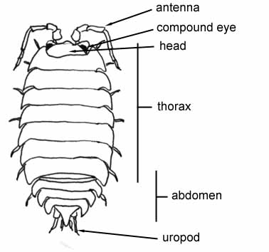**Description:** Wood bugs are small, hard shelled invertebrates with 7 pairs of legs and two antennae. They are about 1.9cm long and have an unique ability to curl up into a ball when they are bothered. They have seven main parts of their body, with five smaller parts and have another unique ability to sense incoming danger behind them with a pair of uropods. They also play a huge role in decomposition.

**Main Parts of the**

**Wood Bug Body:**

**Habitat:** Wood bugs live in very humid climates, because they have to. If they lived in a climate with lower than 50% humidity, then they would die within a day. They mainly live under logs and loose rocks, but do appear under planters and stepping stones in your garden. They are also nocturnal.

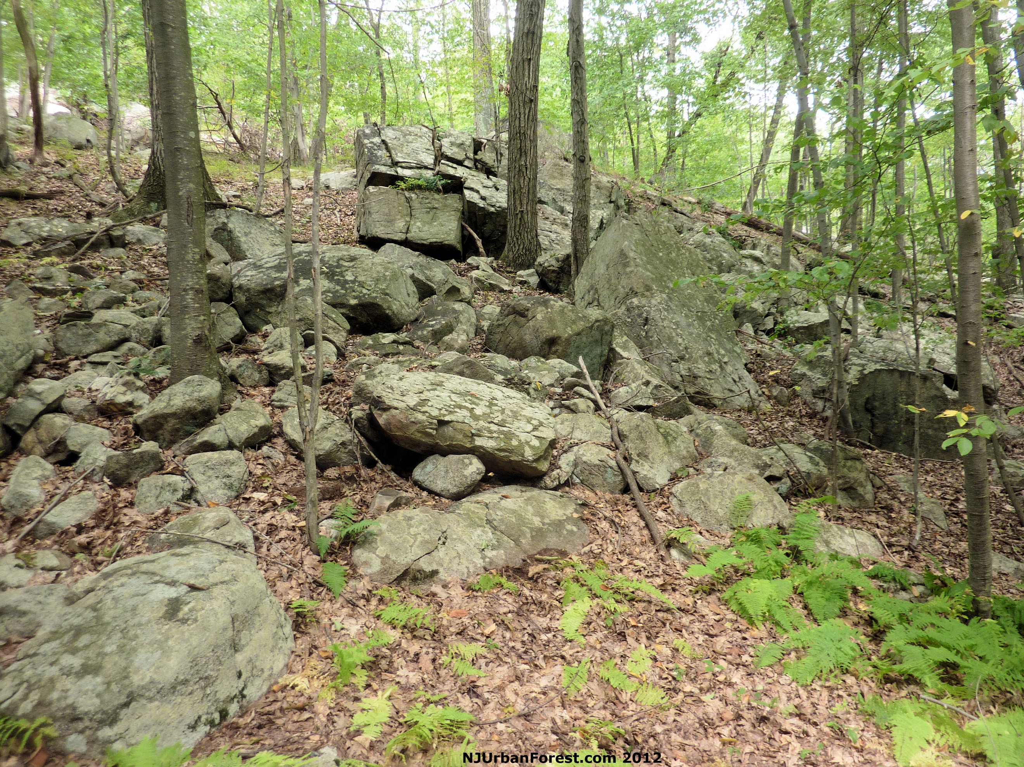

**Question, Hypothesis, Materials & Procedure**

**Question:** How much activity will wood bugs do when they are in different environments, compared to their regular habitat of dirt, darkness, and dry leaves? ______________________________________________________________________________

**Hypothesis:** If wood bugs are in different environments than their regular habitat, then they will be more active by trying to get back to their regular habitat. _____________________________________________________________________________

**Materials:**

1. 3 Metal Trays (6”x12”)
2. 3 Cups of dirt, small twigs and dry leaves
3. 50 ml Water
4. Spoon
5. Tweezers
6. Petri dish cover or similar
7. 6 Wood Bugs
8. Stopwatch
9. Timer

______________________________________________________________________________

**Procedure:**

Environment #1: **Air & Metal** (**Nothing** in tray)

**Preparation:** Take one wood bug and place in tray using tweezers to pick him up. Once the wood bug is in the tray, take the petri dish cover and cover the wood bug, and move it to the center of the tray. Set timer for 2 minutes and ready your stopwatch.

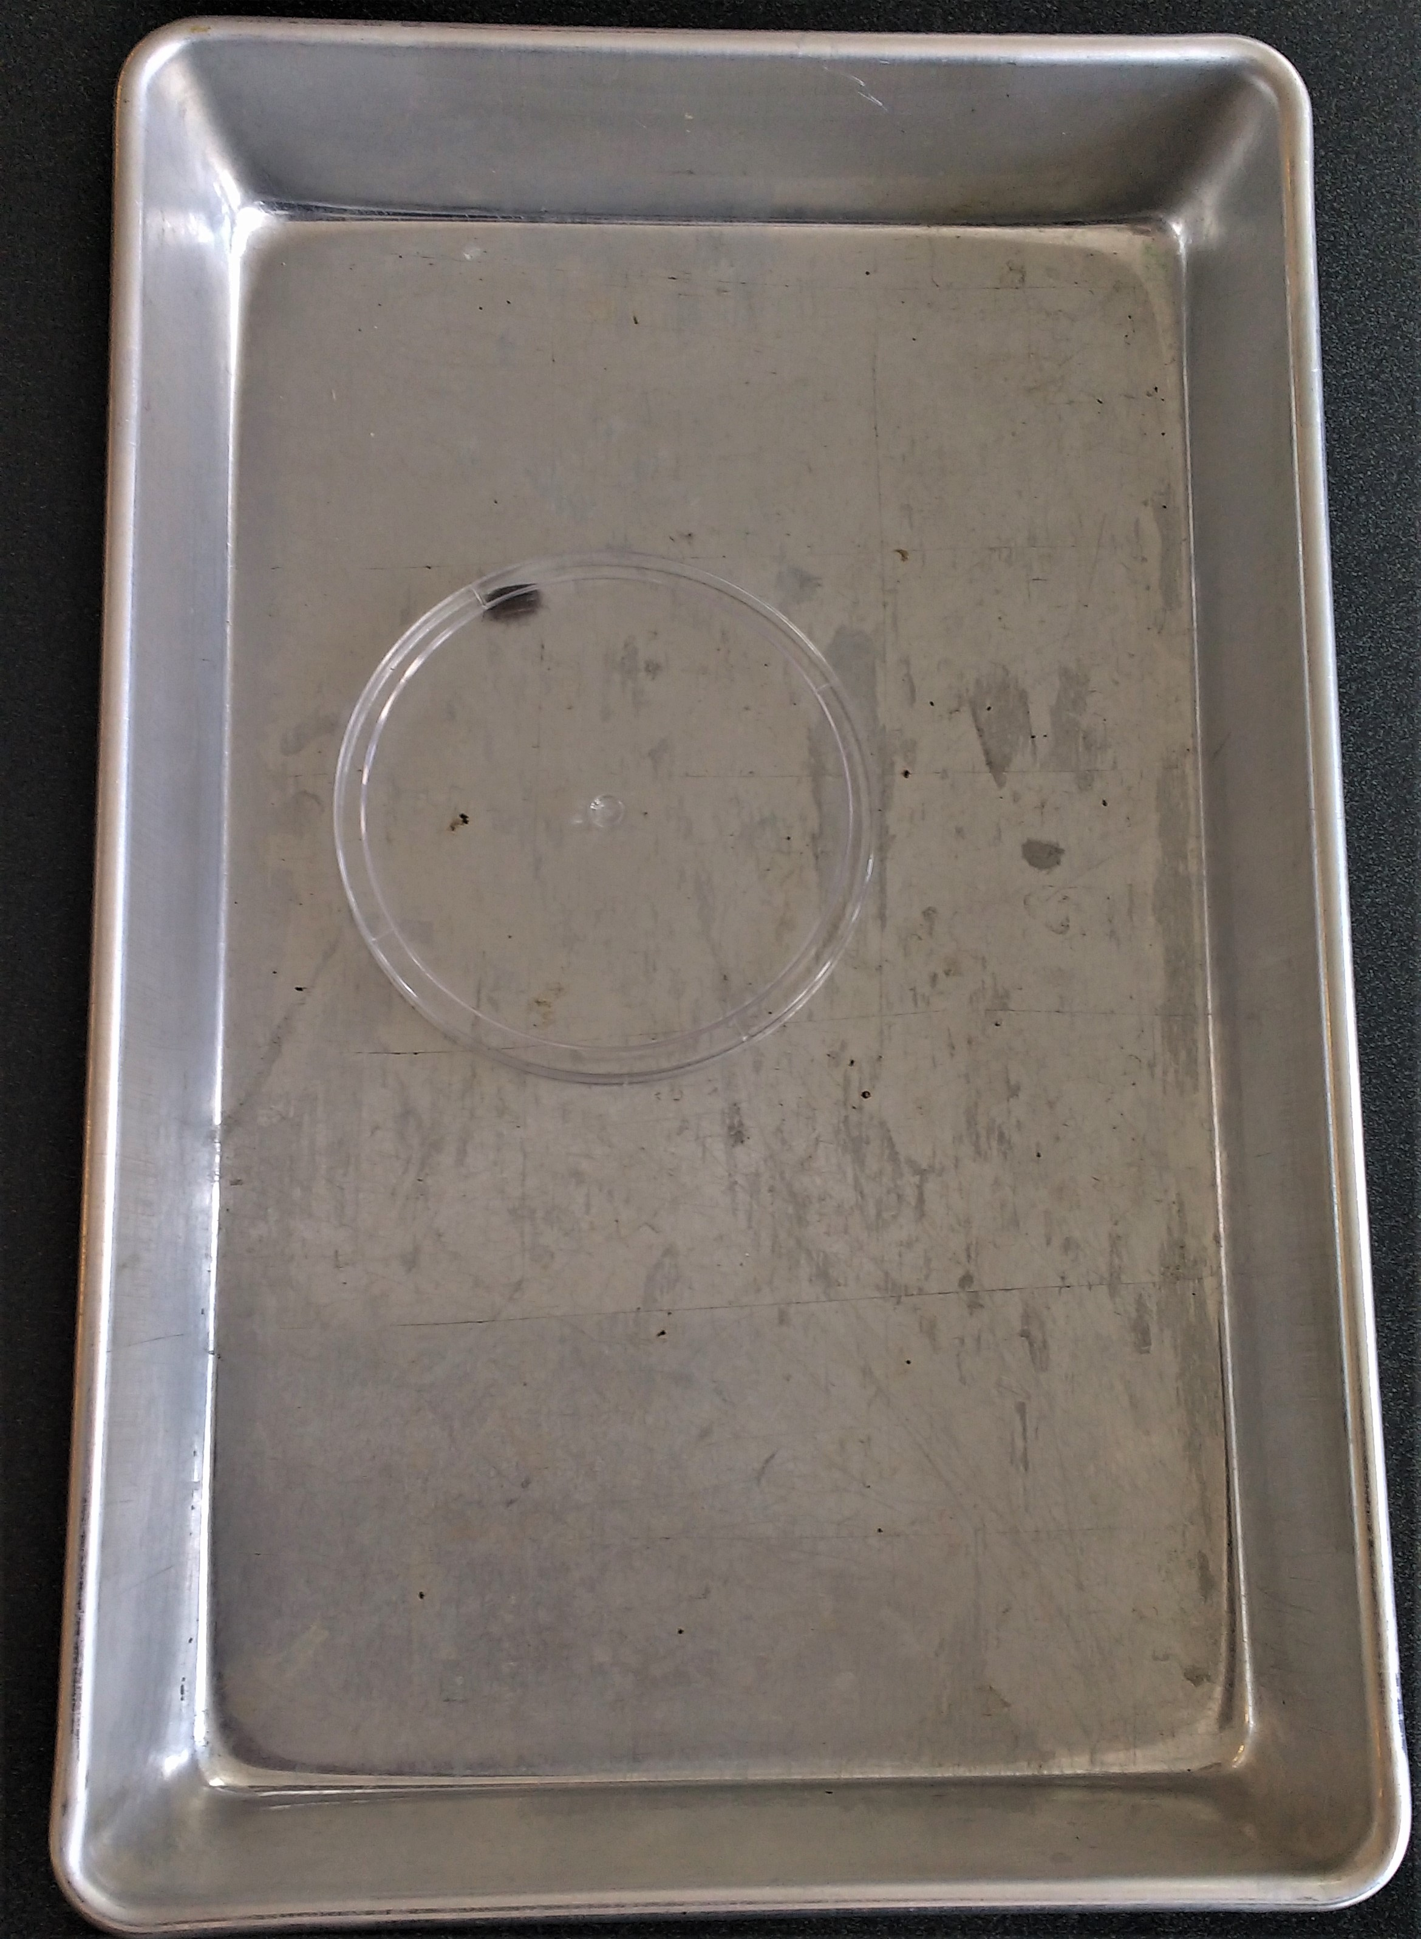

**Steps:**

1. Release cover and at the exact moment, start your timer.
2. As soon as the wood bug starts moving, start your stopwatch. Start and stop the stopwatch per the wood bug’s activity (When the wood bug starts moving, start stopwatch, when wood bug starts moving, start stopwatch). Do this until the timer runs out, and when it does, stop the stopwatch. Someone else should be recording observations and the reaction of the wood bug to this environment.
3. Repeat environment #1 with a different wood bug.

**Question, Hypothesis, Materials & Procedure- Cont’d.**

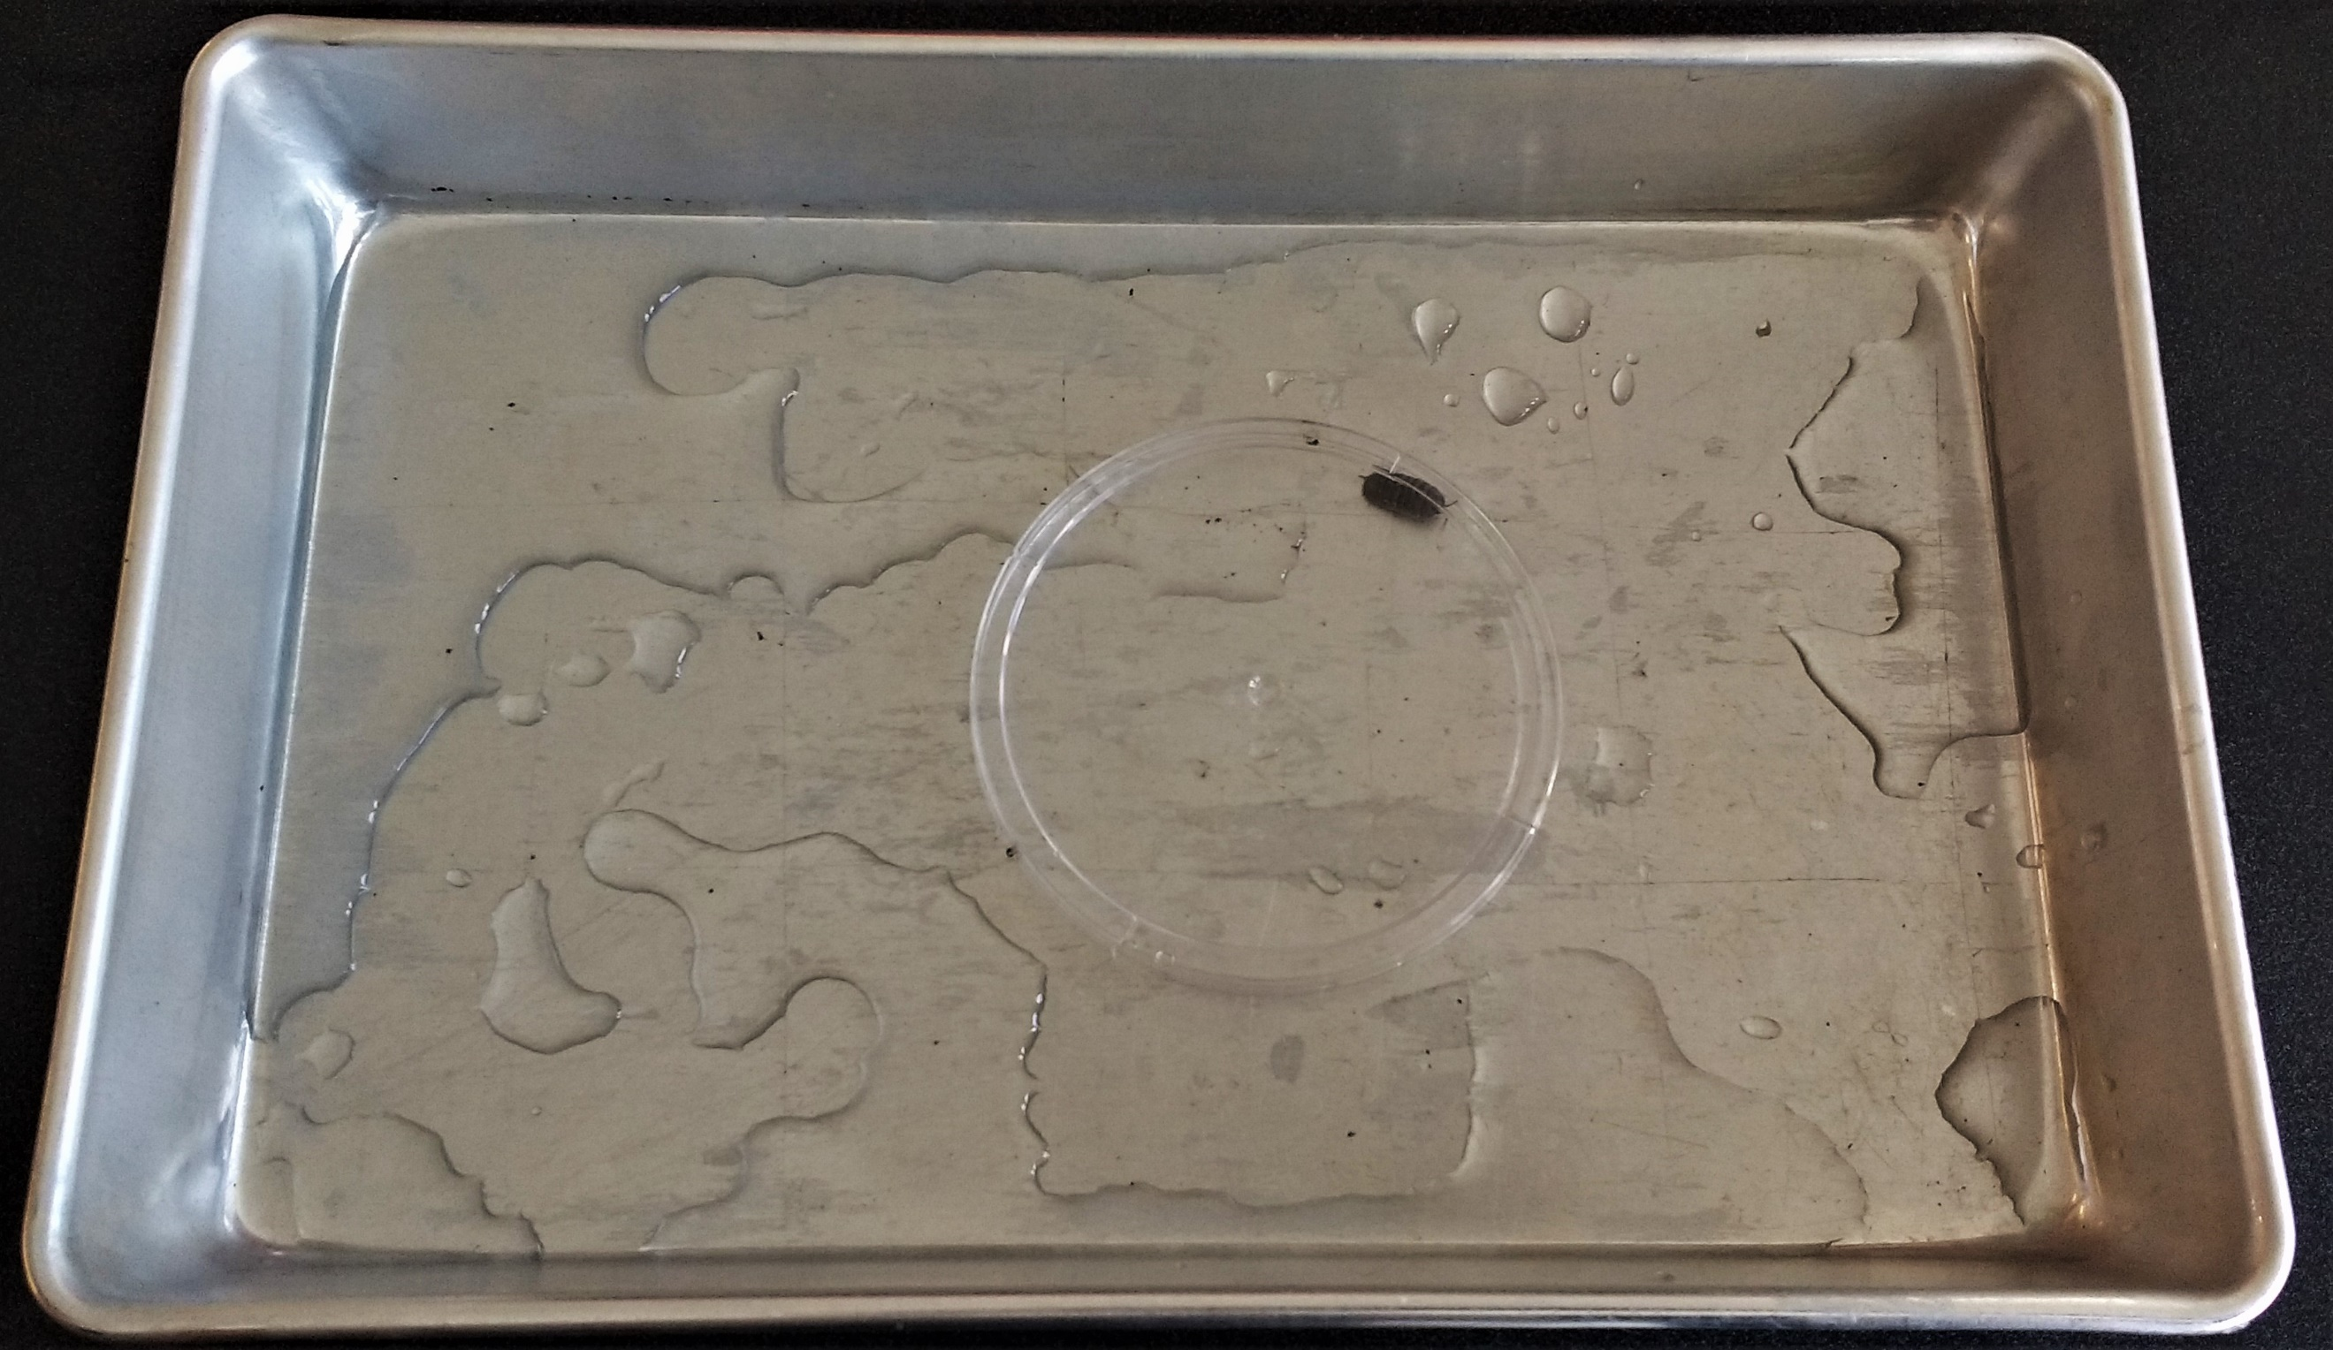Environment #2: **Water & Metal** (**Water** in tray)

**Preparation:** Pour 50 ml of water into the tray, and spread it around evenly. Take one wood bug and place in tray using tweezers to pick him up. Once the wood bug is in the tray, take the petri dish cover and cover the wood bug, and move it to the center of the tray. Set timer for 2 minutes and ready your stopwatch.

**Steps:**

1. Release cover and at the exact moment, start your timer.
2. As soon as the wood bug starts moving, start your stopwatch. Start and stop the stopwatch per the wood bug’s activity (When the wood bug starts moving, start stopwatch, when wood bug starts moving, start stopwatch). Do this until the timer runs out, and when it does, stop the stopwatch. Someone else should be recording observations and the reaction of the wood bug to this environment.
3. Repeat environment #2 with a different wood bug.

Environment #3: **Natural Habitat** (**Dirt, small twigs and dry leaves** in tray)

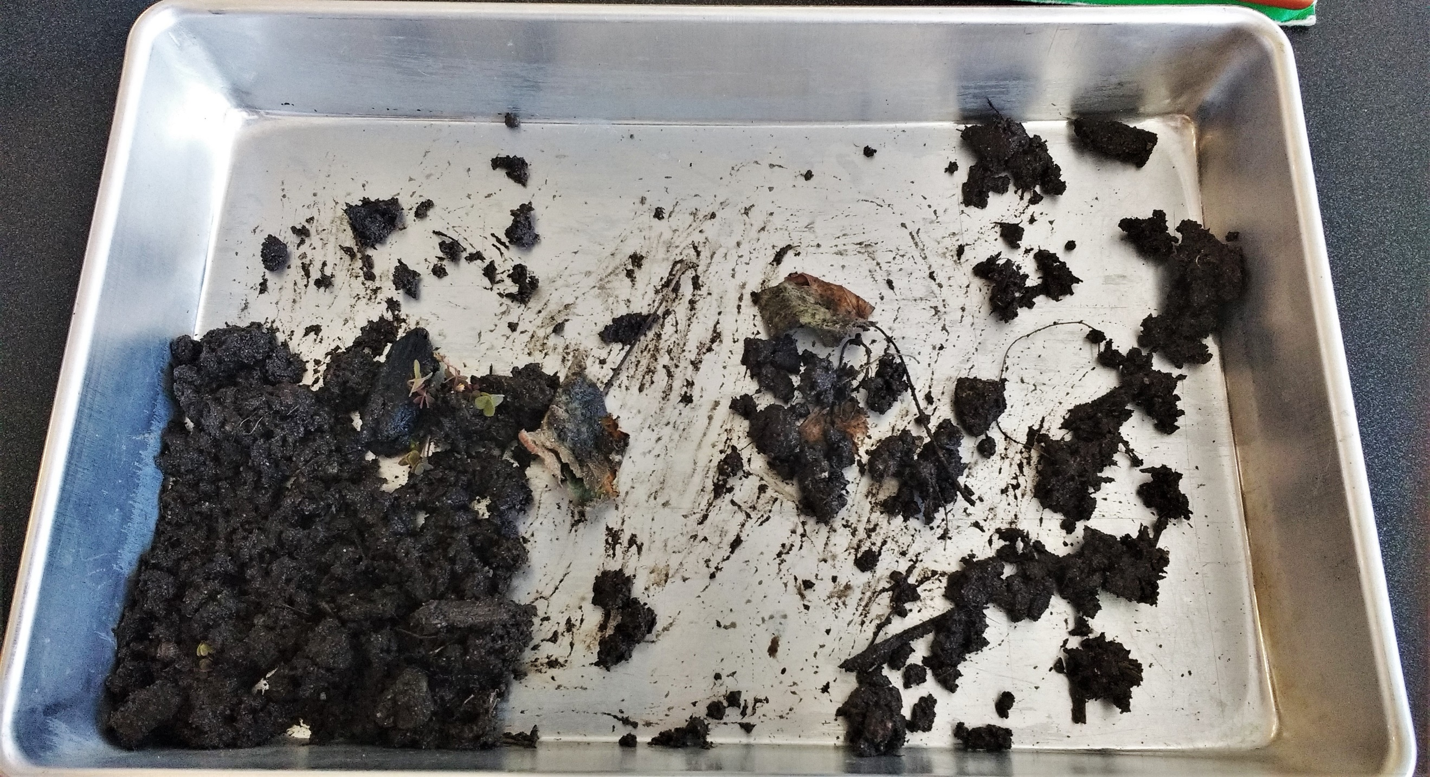**Preparation:** Take the 3 cups of the dirt mixture and pour it into the tray, evenly spreading it loosely. Take one wood bug and place in tray using tweezers to pick him up. Once the wood bug is in the tray, take the petri dish cover and cover the wood bug, and move it to the center of the tray. Set timer for 2 minutes and ready your stopwatch.

**Steps:**

1. Release cover and at the exact moment, start your timer.
2. As soon as the wood bug starts moving, start your stopwatch. Start and stop the stopwatch per the wood bug’s activity (When the wood bug starts moving, start stopwatch, when wood bug starts moving, start stopwatch). Do this until the timer runs out, and when it does, stop the stopwatch. Someone else should be recording observations and the reaction of the wood bug.
3. Repeat environment #3 with a different wood bug.

**Quantitative & Qualitative Observations**

**Activity of Wood Bugs Table:**

|  |  |  |
| --- | --- | --- |
| Environment | Trial Bug#1 | trial Bug #2 |
| regular | **75 sec/2 min** | **64 sec/2 min** |
| Air & metal | **118 sec/2 min** | **107 sec/2 min** |
| Water & Metal | **105 sec/2 min** | **90 sec/2 min** |

**Qualitative Observations:**

**Environment #1: Air & Metal**

**Trial #1:** The wood bug seems to be looking for a way to get out of the tray, obviously failing due to the sides of the tray being vertical. This may indicate that the wood bug may have the intelligence to understand that he is in captivity, and he wants out since all he did was walk around the perimeter of the tray, looking for a way out of his metal enclosure. He finally gave up at 1:30 mins into the experiment, as he went all the way around the tray. It was medium sized.

**Trial #2:** A different wood bug that had a larger body seems to be slower in not only speed, but in intelligence as well. He is constantly trying to climb the sides of the tray, but unlike the previous wood bug this one lack the intelligence to learn and improve, continuously making the same mistake of climbing the sides of the tray. That ended up with him upside down on his back. We had to repeat the experiment because of this problem several times. It finally realized that to not fall over backwards, you have to turn towards the ground.

**Environment #2: Water & Metal**

**Trial #1:** This wood bug seems to not care about the puddles of water, but sees them as some sort of advantage to once again, climb the sides of the tray. The brain of every wood bug seems to constantly have that in mind. This one was medium sized.

**Trial #2:** This larger wood bug seems to be trying to avoid the big patches of water that reside all over the tray. It’s still trying to escape the tray, without touching water. While observing, we noticed how none of the wood bugs have given up by curling up in a ball the way that most wood bugs are perceived to do.

**Qualitative Observations- Cont’d. & Data Analysis Graph**

**Environment #3: Regular Habitat**

**Trial #1:** The wood bug that we are using this time is unlike any of the other wood bugs before, this wood bug is a baby. Because of its small size and inexperience, we’ve observed that the wood bug is trying to maneuver around the dirt environment like we predicted, however, the inexperience of the wood bug must be the cause of its misunderstanding of the terrain. This might have affected our results.

**Trial #2:** This small (but bigger than trial #1’s specimen) wood bug had an easier time maneuvering around their original habitat, and was very calm and relaxed, stopping the most often out of all our wood bugs. It was like he never noticed that he was alone and in a metal tray.

**­­­­­­­­­­­­­­­­­­­­­­­­­­­­­­­­­­­­­­­­­­­­­­­­­­­­­­­­­­­­­**

**Data Analysis Graph**

**Conclusion**

**The data that was collected from our experiment shows that it supports our hypothesis because the normal habitat had less movement than   th**